  - Attachment C: Detailed Technical Specifications
Office Furniture – Specifications and samples

Description | Quantity | Specifications. | Photo provided as sample
Executive Desks L shaped | 2 | - L(160-200) x W(100- 120) cm x H (70-80)  cm  - Built-in Drawers.  - Durable for long- lasting. | 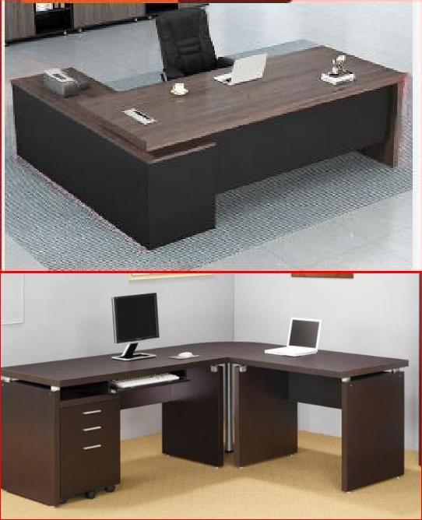
Ronde table | 2 | Round wooden table with 4 set of chairs | 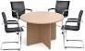
Sofa | 1 |  | 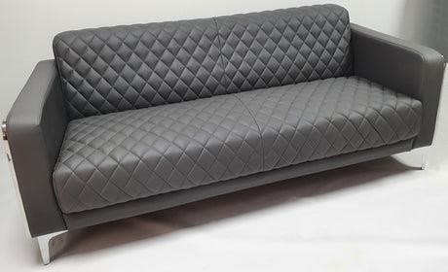
Desks | 17 | - L(140-160) X W(70- 80) cm X H(70-80)  cm  - Built-in drawers  - Durable for long- lasting.

 |  |  | 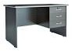
File Cabinet | 2 | Wood glass cabinet | 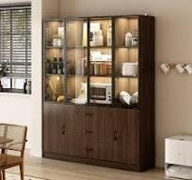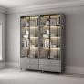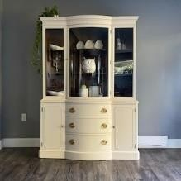
Ergonometric Office chairs with back support. | 19 | - Ergonometric  - Tilting  - Silent and smooth wheels;  - Strong base support and leg. | 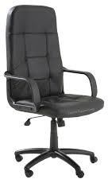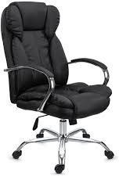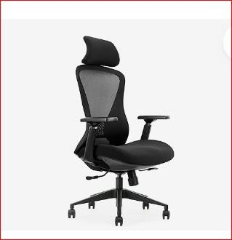
Guest Chairs | 10 | - Upholstered  - Armrest  - Ergonomic Backrest,  - Metal Frame | 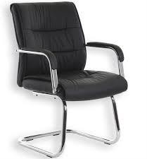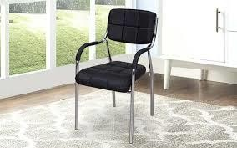
Shelves with two lockable doors | 4 | - Metal  - Two lockable doors | 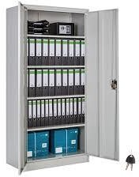
Shelves for binders | 2 | - Metal | 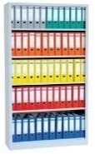

Metal Cabinet with drawers | 1 | - Metal  - 4-5 lockable drawers. | 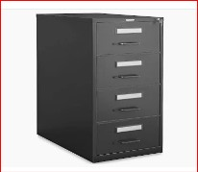
Conference room large table for 15-20 persons. | 1 | - Rectangular  - Seats – 15-20 persons. | 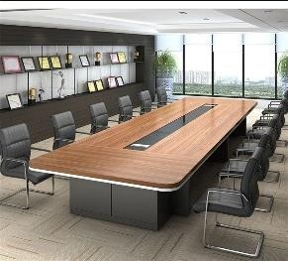
Meeting room chairs. | 20 | - Upholstered  - Armrest  - Ergonomic Backrest,  - Metal Frame | 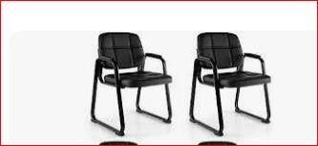
Safe | 1 | Dimensions :  31D x 38W x 60H  Lock type :  Electronic combinaison lock, key :  Product :  Water proof and fire proof  Capacity: 4-5 Cuft. | 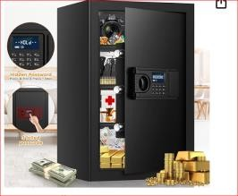

NOTE: The quantities are subject to change based on the Project final needs assessment.

