* 1. **Attachment** **D:** **Instructions** **for** **Obtaining** **a** **Unique** **Entity** **ID** **(SAM)** **DAI’s** **Vendors,** **Subcontractors** **and** **Grantees**

**Note:** **There** **is** **a** **Mandatory** **Requirement** **for** **your** **Organization** **to** **Provide** **a** **Unique** **Entity** **ID** **(SAM)** **to** **DAI**

**I.**

**SUBCONTRACTS/PURCHASE** **ORDERS:** *All* *domestic* *and* *foreign* *organizations* *which* *receive* *first-tier*

*subcontracts/* *purchase* *orders* *with* *a* *value* *of* *$30,000* *and* *greater* *are* *required* *to* *obtain* *a* *Unique* *Entity* *ID* *(SAM)*

*prior* *to* *signing* *the* *agreement.*

**II.**

**MONETARY** **GRANTS:** *All* *U.S.* *organizations* *and* *foreign* *entities* *who* *are* *recipients* *of* *first-tier* *monetary* *grants*

*(fixed* *amount* *awards,* *simplified* *grants,* *or* *standard* *grants)* *of* *any* *value* *are* *required* *to* *obtain* *a* *Unique* *Entity* *ID* *(SAM)* *prior* *to* *signing* *the* *agreement;*

**NO** **SUBCONTRACTS/POs** **($30,000** **+** **greater)** **or** **MONETARY** **GRANTS** **WILL** **BE** **SIGNED** **BY** **DAI** **WITHOUT** **PRIOR** **RECEIPT** **OF** **A** **UNIQUE** **ENTITY** **ID** **(SAM).**

*Note:* *The* *determination* *of* *a* *successful* *offeror/applicant* *resulting* *from* *this* *RFP/RFQ/RFA* *is* *contingent* *upon* *the* *winner* *providing* *a* *Unique* *Entity* *ID* *(SAM)to* *DAI.* *Organizations* *who* *fail* *to* *provide* *a* *Unique* *Entity* *ID* *(SAM)* *will* *not* *receive* *an* *award* *and* *DAI* *will* *select* *an* *alternate* *vendor/subcontractor/grantee.*

***--------------------------------------------------------------------------------------------------------------------------***

**Background:**

**Summary** **of** **Current** **U.S.** **Government** **Requirements** **-** **Unique** **Entity** **ID** **(SAM)**

*Effective* *April* *4,* *2022,* *entities* *doing* *business* *with* *the* *federal* *government* *will* *use* *the* *Unique* *Entity* *Identifier* *(SAM)* *created* *in* *SAM.gov.* *The* *Unique* *Entity* *ID* *(SAM)* *is* *a* *12-character* *alphanumeric* *value* *managed,* *granted,* *and* *owned* *by* *the* *government.* *This* *allows* *the* *government* *to* *streamline* *the* *entity* *identification* *and* *validation* *process,* *making* *it* *easier* *and* *less* *burdensome* *for* *entities* *to* *do* *business* *with* *the* *federal* *government.*

*Entities* *are* *assigned* *an* *identifier* *during* *registration,* *or* *one* *can* *be* *requested* *at* *SAM.gov* *without* *needing* *to* *register.* *Ernst* *and* *Young* *provides* *the* *validation* *services* *for* *the* *U.S.* *Government.* *The* *information* *required* *for* *getting* *a* *Unique* *Entity* *ID* *(SAM)* *without* *registration* *is* *minimal.* *It* *only* *validates* *your* *organization's* *legal* *business* *name* *and* *address.* *It* *is* *a* *verification* *that* *your* *organization* *is* *what* *you* *say* *it* *is.*

*The* *Unique* *Entity* *ID* *(SAM)* *does* *not* *expire.*

**Summary** **of** **Previous** **U.S.** **Government** **Requirements** **–** **DUNS**

*The* *Data* *Universal* *Numbering* *System* *(DUNS)* *is* *a* *system* *developed* *and* *managed* *by* *Dun* *and* *Bradstreet* *that* *assigns* *a* *unique* *nine-digit* *identifier* *to* *a* *business* *entity.* *It* *is* *a* *common* *standard* *world-wide* *and* *was* *previously* *used* *by* *the* *U.S.* *Government* *to* *assign* *unique* *entity* *identifiers.* *This* *system* *was* *retired* *by* *the* *U.S.* *Government* *on* *April* *4,* *2022* *and* *replaced* *with* *the* *Unique*

*Entity* *Identifier* *(SAM).* *After* *April* *4,* *2022* *the* *federal* *government* *will* *have* *no* *requirements* *for* *the* *DUNS* *number.*

*If* *the* *entity* *was* *registered* *in* *SAM.gov* *(active* *or* *inactive* *registration),* *a* *Unique* *Entity* *ID* *(SAM)* *was* *assigned* *and* *viewable* *in* *the* *entity* *registration* *record* *in* *SAM.gov* *prior* *to* *the* *April* *4,* *2022* *transition.* *The* *Unique* *Entity* *ID* *(SAM)* *can* *be* *found* *by* *signing* *into* *SAM.gov* *and* *selecting* *the* *Entity* *Management* *widget* *in* *your* *Workspace* *or* *by* *signing* *in* *and* *searching* *entity* *information.*

**Instructions** **detailing** **the** **process** **to** **be** **followed** **in** **order** **to** **obtain** **a** **Unique** **Entity** **ID** **(SAM)** **for** **your** **organization** **begin** **on** **the** **next** **page.**

## THE PROCESS FOR OBTAINING AN UNIQUE ENTITY ID IS OUTLINED BELOW:

1. *Have* *the* *following* *information* *ready* *to* *request* *a* *Unique* *Entity* *ID* *(SAM)*
   1. *Legal* *Business* *Name*
   2. *Physical* *Address* *(including* *ZIP* *+* *4)*
   3. *SAM.gov* *account* *(this* *is* *a* *user* *account,* *not* *actual* *SAM.gov* *business* *registration).*
      1. **As** **a** **new** **user***,* *to* *get* *a* *SAM.gov* *account,* *go* *to* [*www.sam.gov.*](http://www.sam.gov/)
         1. *Click* *“Sign* *In”* *on* *the* *upper* *right* *hand* *corner.*
         2. *Click* *on* *“Create* *a* *User* *Account”*

* + - 1. *Choose* *Account* *Type:*
         1. *Create* *an* *Individual* *User* *Account* *to* *perform* *tasks* *such* *as* *register/update* *your* *entity,* *create,* *and* *manage* *exclusion* *records* *or* *to* *view* *FOUO* *level* *data* *for* *entity* *records.*
         2. *Create* *a* *System* *User* *Account* *if* *you* *need* *system-to-* *system* *communication* *or* *if* *performing* *data* *transfer* *from* *SAM* *to* *your* *government* *database* *system.*

*Complete* *the* *requested* *information,* *and* *then* *click* *“Submit.”*

* + - 1. *Click* *“DONE”* *on* *the* *confirmation* *page.* *You* *will* *receive* *an* *email* *confirming* *you* *have* *created* *a* *user* *account* *in* *SAM.*
      2. *Click* *the* *validation* *link* *in* *the* *email* *that* *contains* *the* *activation* *code* *within* *48* *hours* *to* *activate* *your* *user* *account.* *If* *the* *email* *link* *is* *not* *hyperlinked* *(i.e.,* *underlined* *or* *appearing* *in* *a* *different* *color),* *please* *copy* *the* *validation* *link* *and* *paste* *it* *into* *the* *browser* *address* *bar.* *You* *can* *now* *register* *an* *entity.*

*NOTE:* *Creating* *a* *user* *account* *does* *not* *create* *a* *registration* *in* *SAM,* *nor* *will* *it* *update/renew* *an* *existing* *registration* *in* *SAM.*

1. *Once* *you* *have* *registered* *as* *a* *user,* *you* *can* *get* *a* *Unique* *Entity* *ID* *by* *selecting* *the* *“Get* *Started”* *button* *on* *the* *SAM.gov* *home* *page.*

1. *Select* *“Get* *Started”* *on* *the* *Getting* *Started* *with* *Registration* *page.*

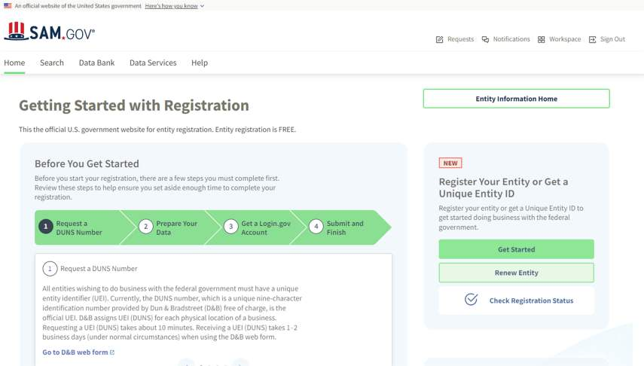

1. A screenshot of a computer

   Description automatically generated*Select* *“Get* *Unique* *Entity* *ID”* *on* *the* *Get* *Started* *page.*
2. *Enter* *Entity* *Information.*

* 1. *If* *you* *previously* *had* *a* *DUN* *Number,* *make* *sure* *your* *Legal* *Business* *Name* *and* *Physical* *Address* *are* *accurate* *and* *match* *the* *Entity* *Information,* *down* *to* *capitalization* *and* *punctuation,* *used* *for* *DUNS* *registration.*

1. *When* *you* *are* *ready,* *select* *“Next”*
2. *Confirm* *your* *company’s* *information.*

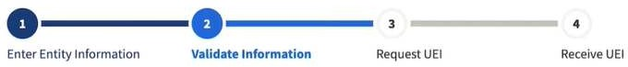

* 1. A screenshot of a computer

     Description automatically generated*On* *this* *page* *you* *will* *have* *the* *option* *to* *restrict* *the* *public* *search* *of* *this* *information.* *“Allow* *the* *selected* *record* *to* *be* *a* *public* *display* *record.”* *If* *you* *uncheck* *this* *box,* *only* *you* *and* *the* *federal* *government* *users* *will* *be* *able* *to* *search* *and* *view* *the* *entity* *information* *and* *entities* *like* *DAI* *will* *not* *be* *able* *to* *independently* *verify* *that* *you* *have* *a* *Unique* *Entity* *Identifier* *(SAM).*

1. *When* *you* *are* *ready,* *select* *“Next”*
2. *Once* *validation* *is* *completed,* *select* *“Request* *UEI”* *to* *be* *assigned* *a* *Unique* *Entity* *ID* *(SAM).* *Before* *requesting* *your* *UEI* *(SAM),* *you* *must* *certify* *that* *you* *are* *authorized* *to* *conduct* *transactions* *under* *penalty* *of* *law* *to* *reduce* *the* *likelihood* *of* *unauthorized* *transactions* *conducted* *for* *the* *entity.*

1. *The* *Unique* *Entity* *ID* *will* *be* *shown* *on* *the* *next* *page.* *SAM.gov* *will* *send* *an* *email* *confirmation* *with* *your* *Unique* *Entity* *ID.*

1. *If* *you* *need* *to* *view* *the* *Unique* *Entity* *ID* *from* *SAM* *in* *the* *future* *or* *update* *the* *organization’s* *information,* *sign* *into* *SAM.gov* *and* *go* *to* *“Entity* *Management”* *widget.*